Team leader:

Ahmed Mohamed aboelfetouh salem

Id_team_leader:

20191700061

• Team members

|  |  |
| --- | --- |
| 20191700054 | Ahmed mabrouk fekry abdelfattah |
| 20191700055 | Ahmed magdy ahmed ali |
| 20191700061 | Ahmed Mohamed aboelfetouh salem |
| 20191700181 | Bassam Mohamed kamal hassan |
| 20191700459 | Kamal salah kamal aboelkheir |

• Map creation

1-Open house world

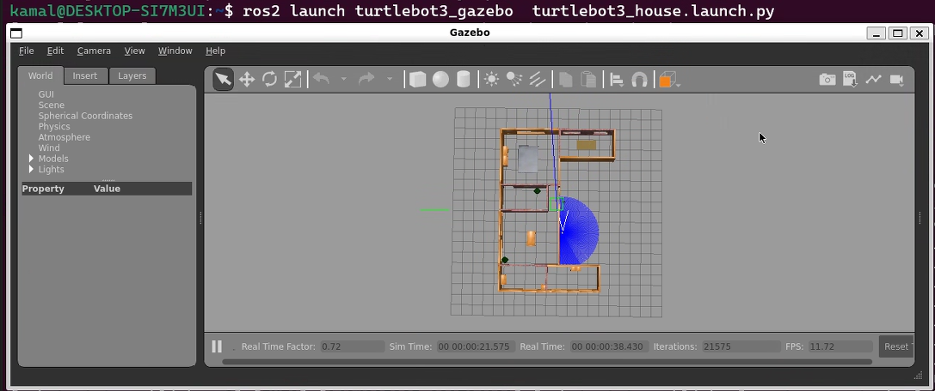

2-Open Rviz2

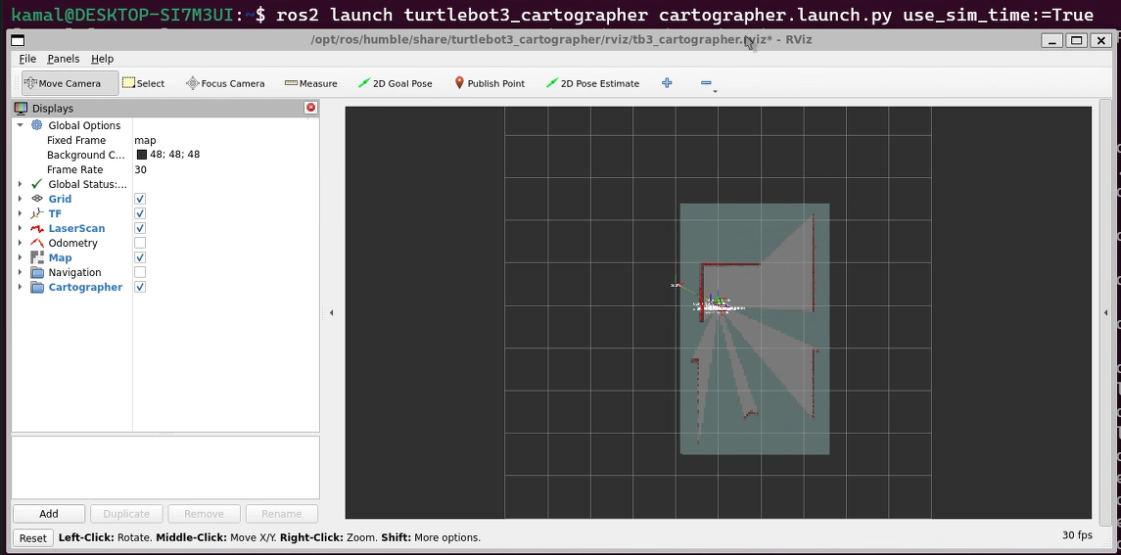

3- Including keyboard control

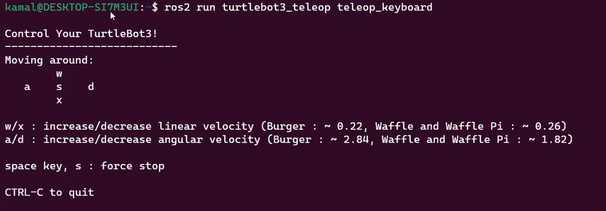

4- Building the map

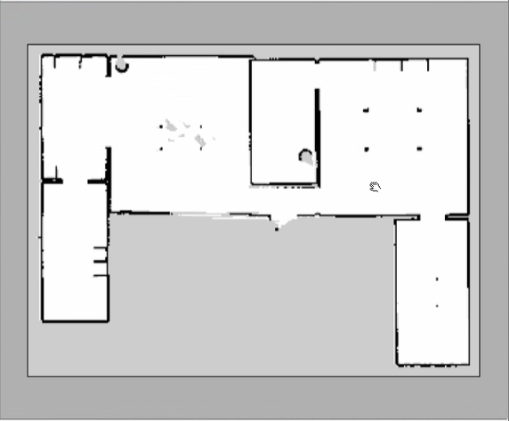

**To save this map**

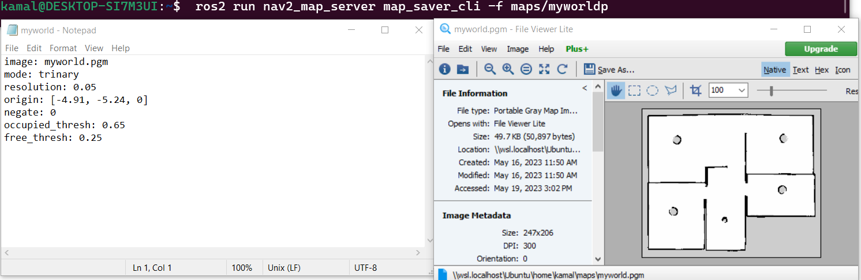

**• Navigation inside the house world**

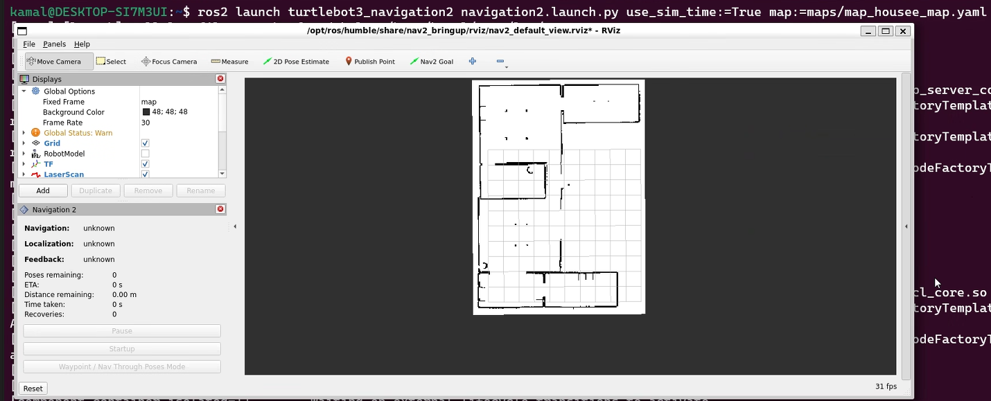

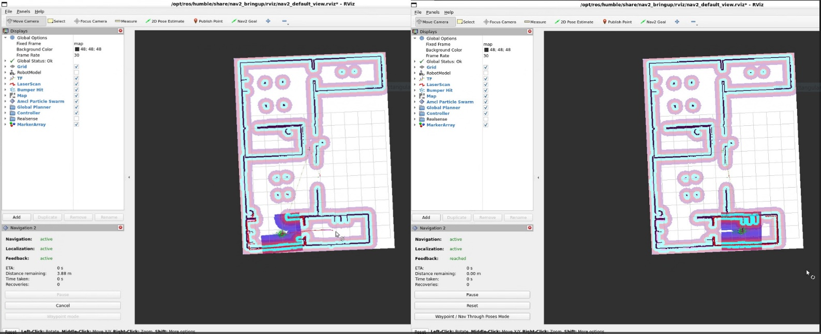

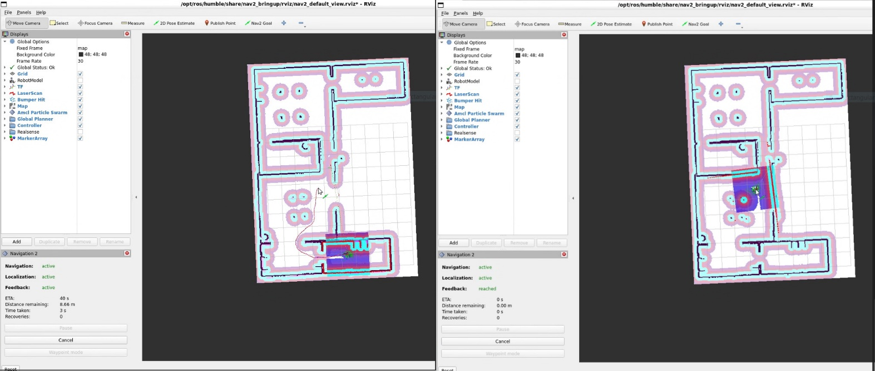

**Model creation •**

1-Open gazebo

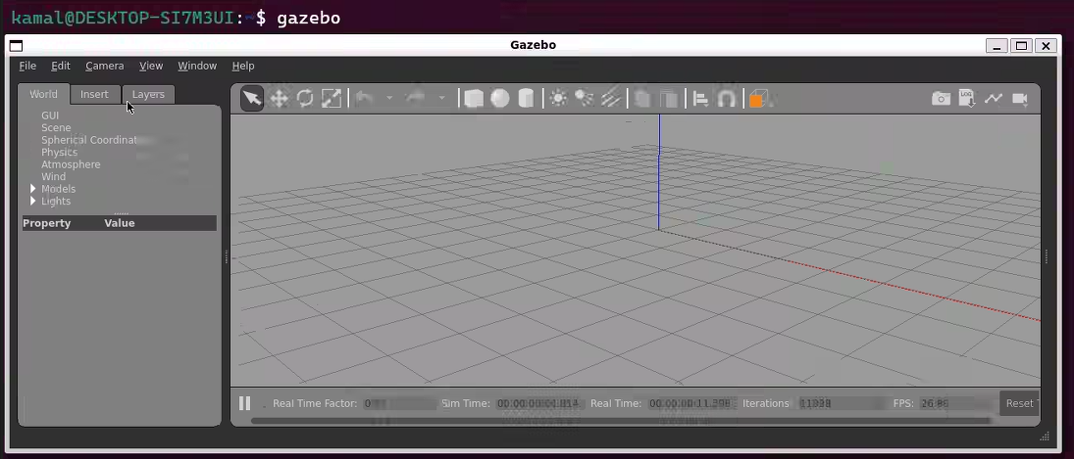

2- create our model

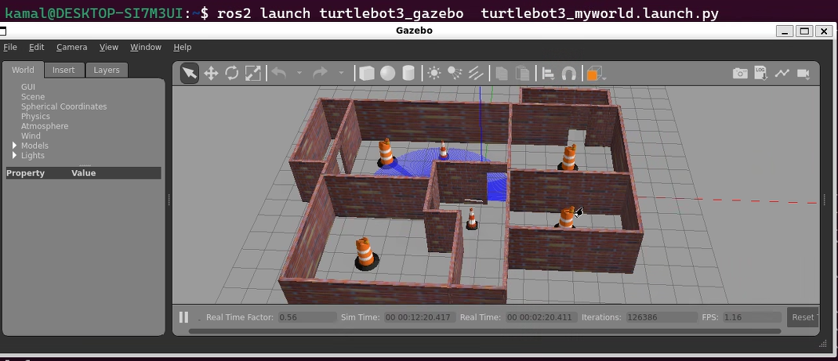

2-create maze model

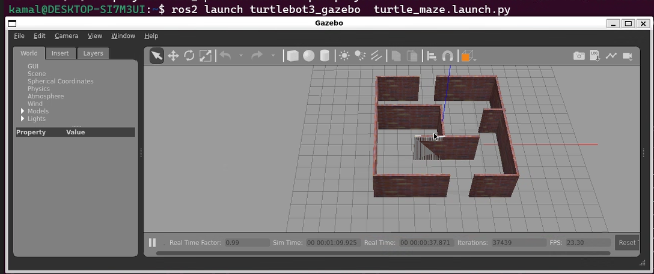

3- Save all previous models with extension ".wold"

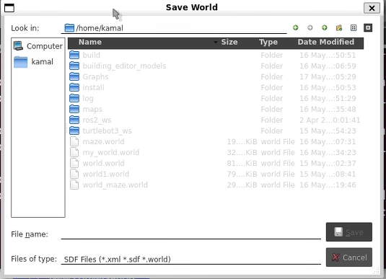

**Navigation in my world•**

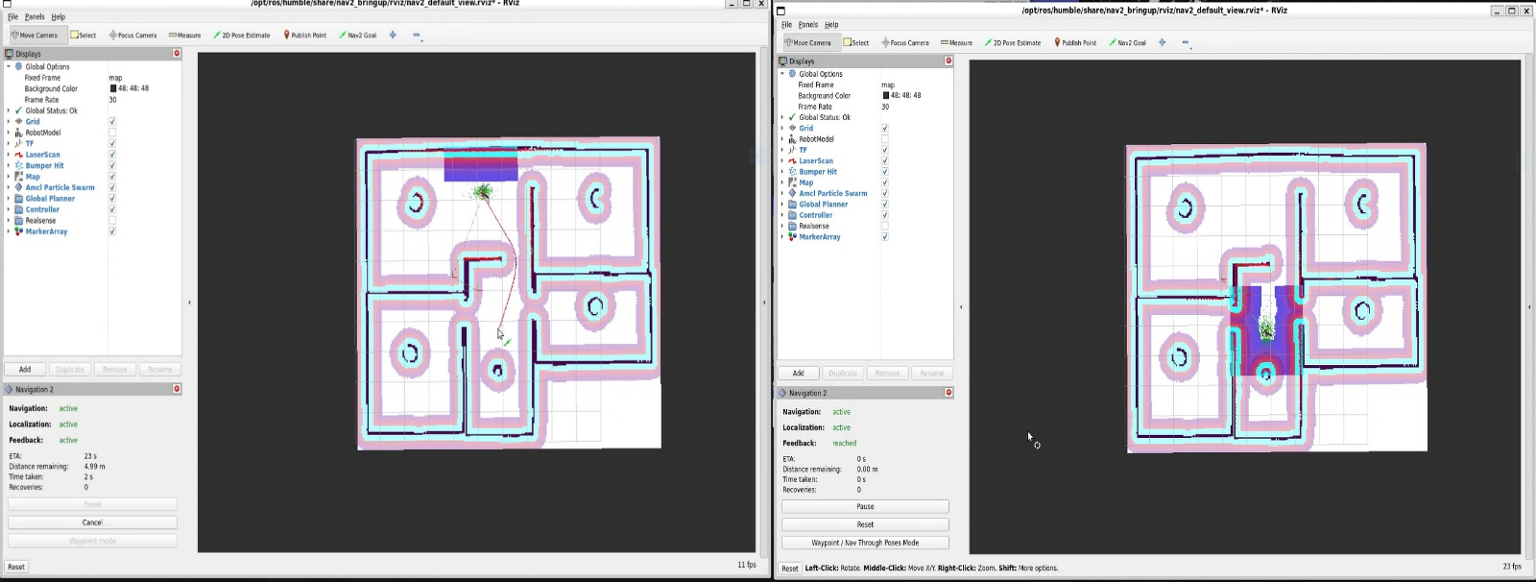

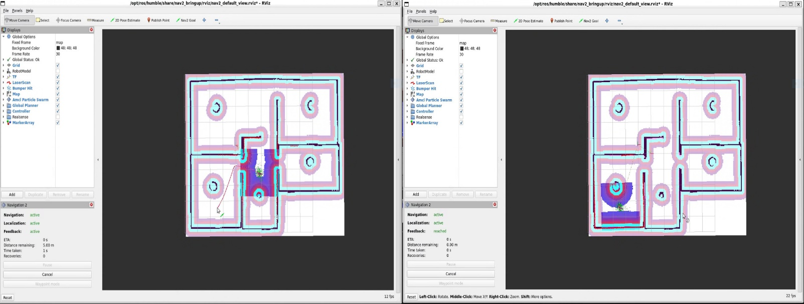

**Explore topics and goals when navigating**

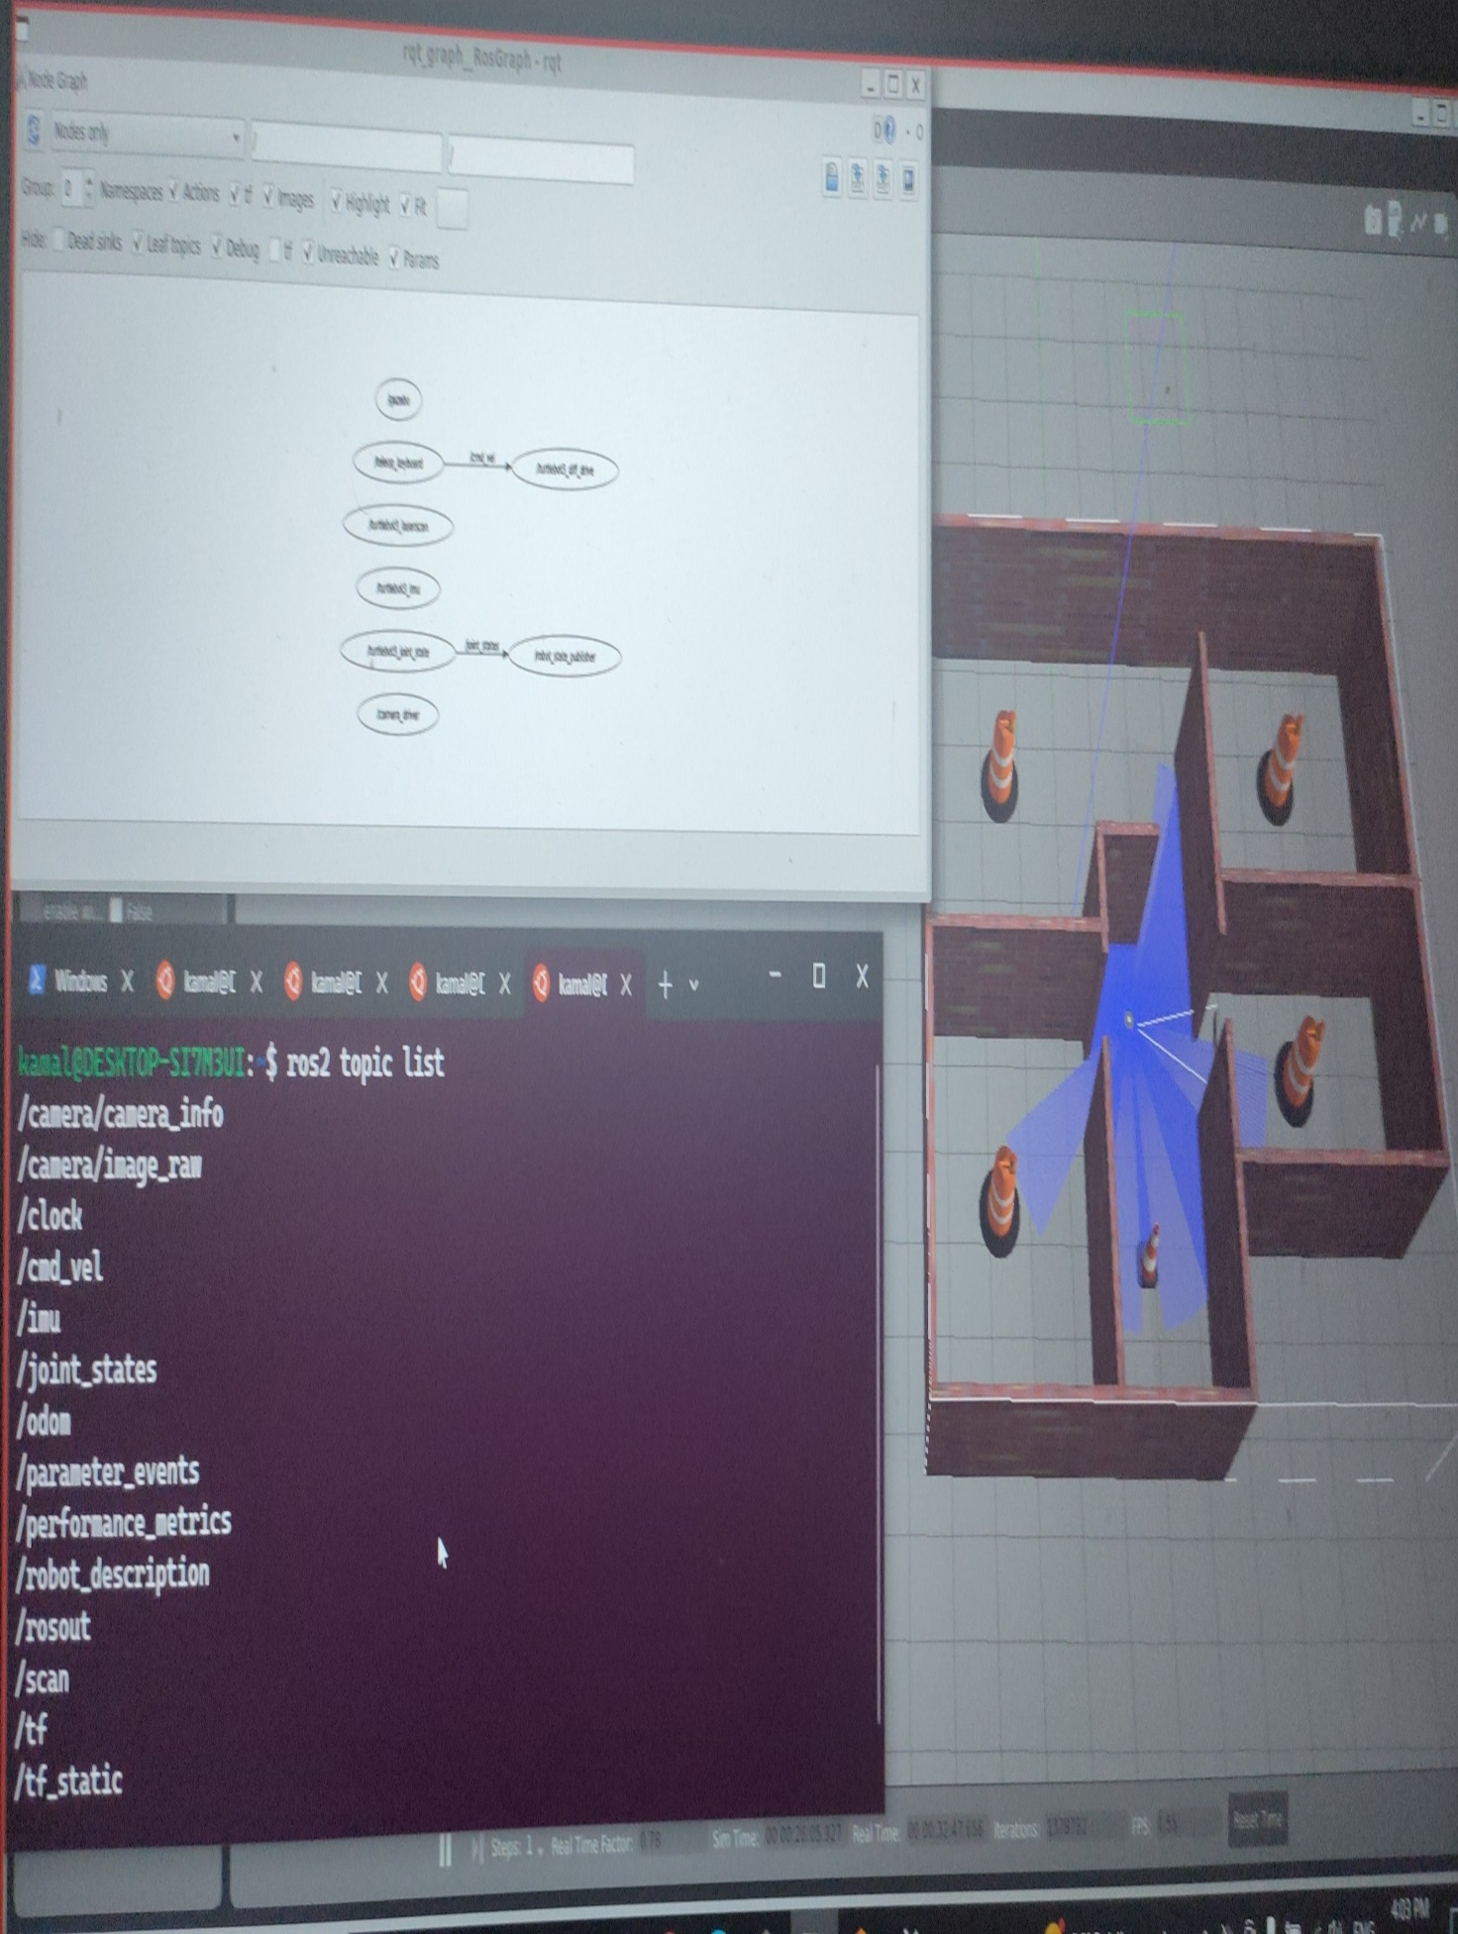

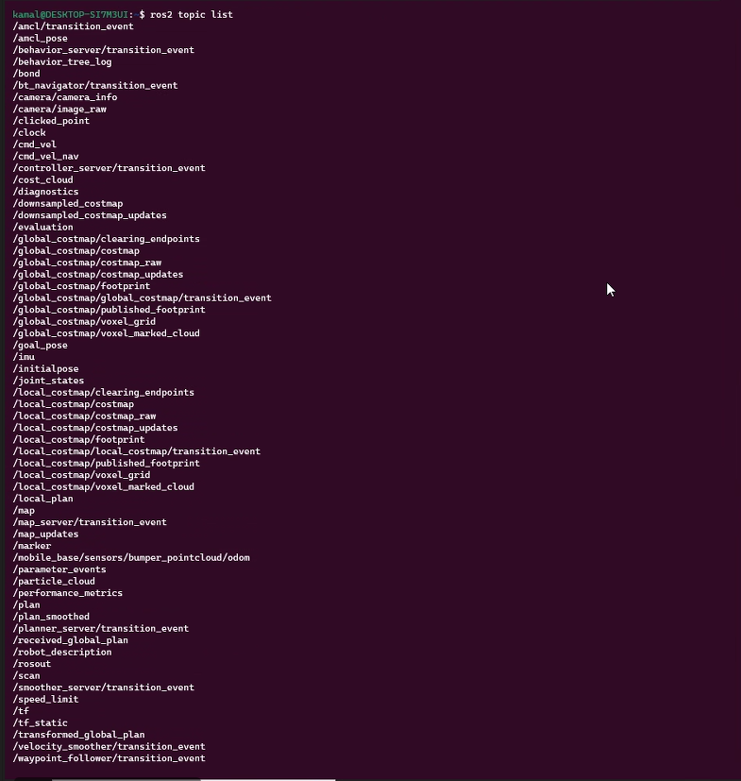

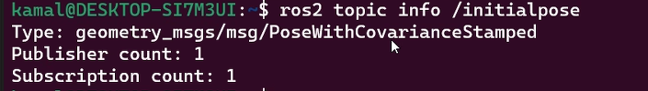

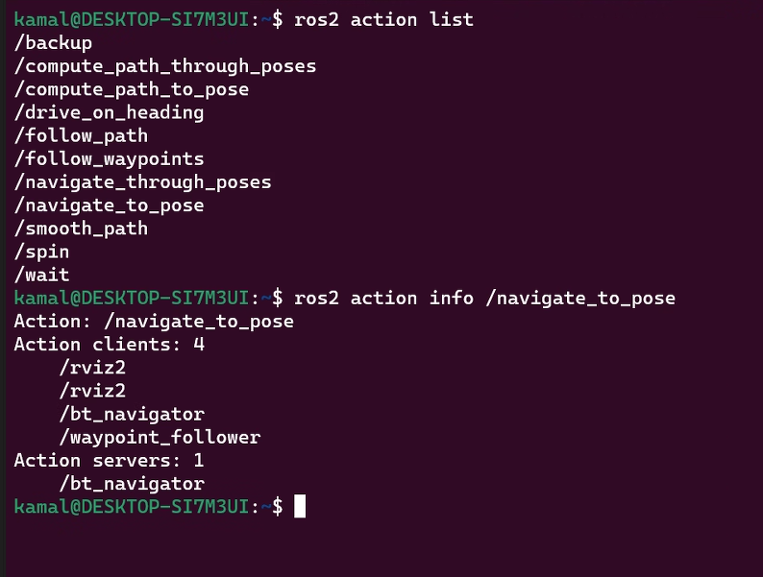

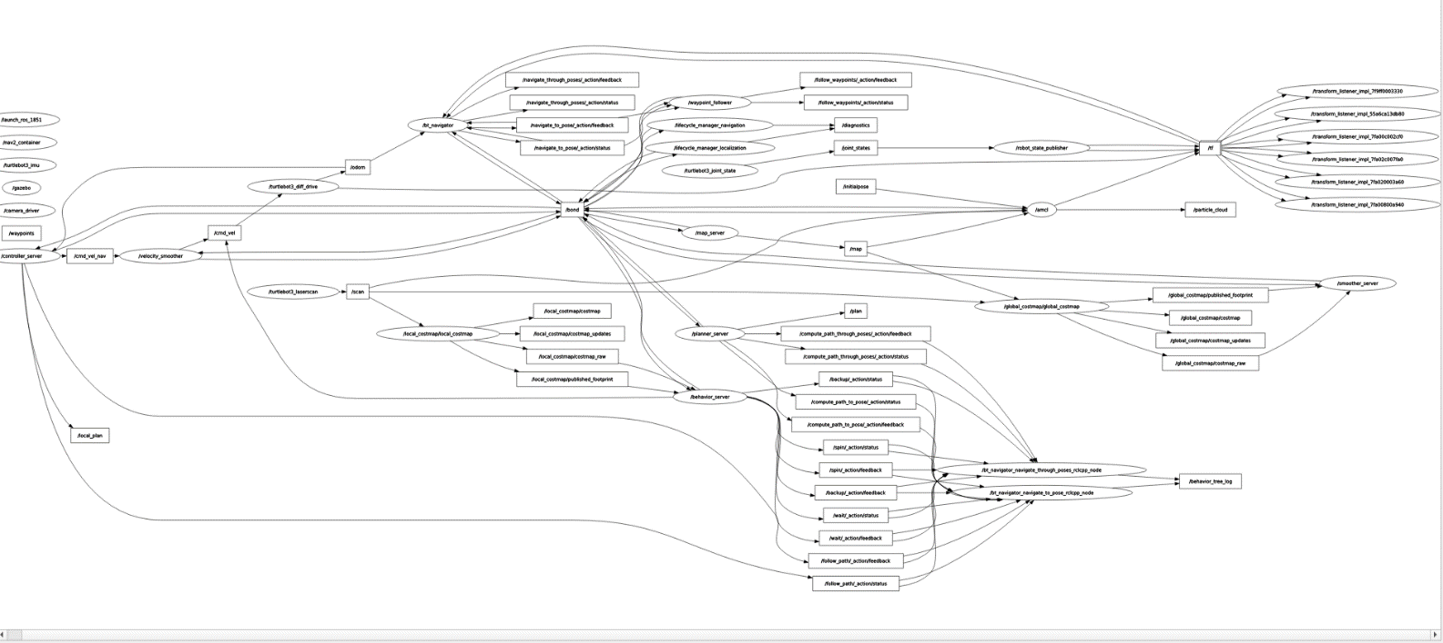

* **To get clone from git gub**

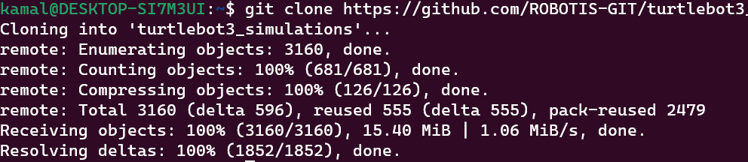

* **To update at bashrc**

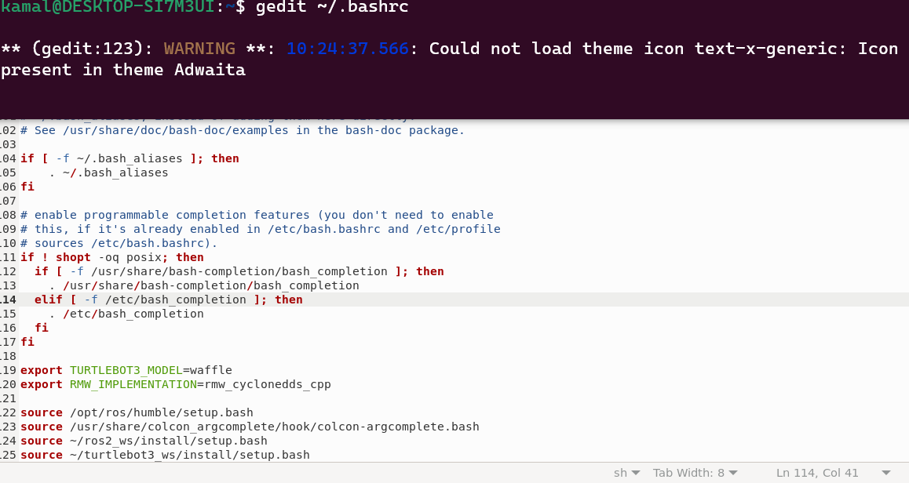

* **To change the mode of the node**

**chmod +x turtlebot3_node.launch.py**

**Thank you ♡**